“Python Maze Solver – User Manual”

1. Requirements …………………………… 1
2. Run Code …………………………… 1
3. Menu …………………………… 2
4. Exit …………………………… 2

**1.- Requirements**

To run this program, you need to be in the root folder and run the following lines in the command prompt.

pip install -r requirements.txt

**2.- Run Code**

Once you have installed all the libraries the programs need, you can easily run your program by clicking the play bottom on your favorite Python IDLE in the file “routes.py”. Then you will see on the command line the run of the program, and there you can find the route of the Web Application.

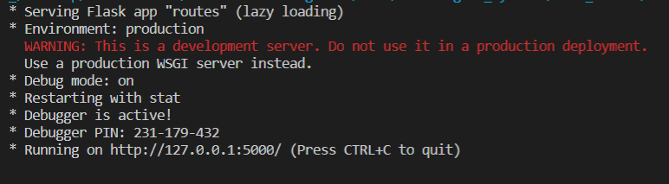

Link: http://127.0.0.1:5000/

Once you click in the link, it will open one page on your default browser. Where you will be able to see the Main Screen.

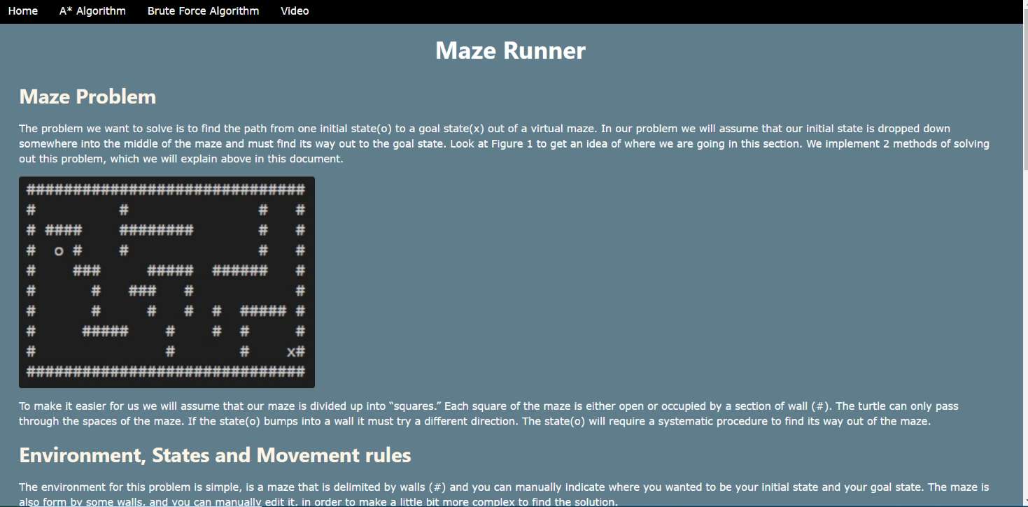

**3.- Main Menu**

You will have 4 options once you are running the python code.

* Home: A page where you can find all the documentation of the problem, the environment description, the cost and heuristic functions, and the description of the algorithms utilized for this problem.
* A* Algorithm: A page for generate and display the maze problem, using A* Search Algorithm.  
  Brute Force Algorithm: A page for generate and display the maze problem, using Brute Force.
* Video: A page for displaying the video of this problem.

**4.- Exit Program**

Close the browser or the tab. And close the Python IDLE.